**T.C.**

**İSTANBUL ATLAS ÜNİVERSİTESİ**

**MÜHENDİSLİK VE DOĞA BİLİMLERİ**

**FAKÜLTESİ**



**Project name**

**Self-built UAV quadcopter drone**

**Name Surname student number**

**Izzeldin Alashqar 210504516**

**Bachelor’s Degree Graduation Thesis**

**Software Engineering**

**Department of Software Engineering**

Advisor

Prof. Dr. Naim Ajlouni

May, 2025

**Özet**

Bu projede, insansız hava aracı (UAV) anlamına gelen bir otonom drone inşa etmeyi hedefliyoruz. Bu proje, FlySky kontrol cihazını kullanarak bir drone uçurmayı içermektedir. Alıcı tarafından bir kontrol sinyalinin iletilmesi ve kontrol cihazının bu sinyali toplayarak kontrol işlemini mümkün kılan bir verici olarak çalışması ile gerçekleştirilir. Bu UAV drone, X şeklinde tasarlanmış 4 pervaneye sahip bir quadcopter drone’dur. Her dikey pervane, diğer 2 pervaneden farklı bir şekilde hareket eder. Bir quadcopter ileriye gitmek için ön pervanelerin hızı yavaşlatılırken, arka pervanelerin hızı artırılır; bu da "pitch" hareketine neden olur. Çapraz motorların birbirine zıt yönde dönmesinin bir diğer nedeni, tepkime torkunu tamamen iptal etmektir. Böylece, drone’un "yaw" veya dönme hareketi, bir veya birden fazla pervanenin hızını yavaşlatarak sağlanabilir. Bu durum, verici ve alıcı tarafından desteklenir. Quadcopter, havada sabit kaldığı durumda 250 g'a kadar yük bozulmasını tolere edebilir. Quadcopter'in maksimum çalışma süresi, 5200mAh lityum-polimer batarya kullanılarak yaklaşık altmış dakikadır ve bu süre, daha yüksek kapasiteli bir batarya kullanılarak artırılabilir. Bu özelliklere ek olarak, Quadcopter akıllı bir video alıcı-verici ile canlı video yayını yapabilir.

**ANAHTAR KELİMELER**: iletişim, hareket, yük bozulması, zaman, batarya, Quadrotor, Aerodinamik, Elektronik, Sonlu Elemanlar Analizi, Gövde, vb.

**Abstract (1)(3)**

This project focuses on the design and development of a self-built UAV (Unmanned Aerial Vehicle) quadcopter using a FlySky controller. The system operates through the transmission of control signals from the controller to a receiver on the drone, enabling real-time manual flight control. The quadcopter features an X-shaped frame with four propellers, each configured to rotate in alternating directions to ensure balance and stability. Forward motion is achieved by decreasing the speed of the front propellers while increasing the rear ones, inducing a pitch effect. Yaw rotation is controlled by manipulating the rotational torque through opposing motor speeds.

The drone is designed to hover with the ability to tolerate load disturbances of up to 250 grams. Powered by a 5200mAh lithium-polymer battery, it offers a maximum estimated flight time of 60 minutes under optimal conditions. Additionally, the UAV can be equipped with a live video transmission system via a smart video transceiver, enabling real-time visual feedback for applications such as surveillance and diagnostics. The overall design integrates both mechanical and electronic components and provides a modular foundation for further expansion with sensors or autonomous functionality.

**KEYWORDS:** communication, moving, load disturbance, time, battery, *Quadrotor, Aerodynamics, Electronics, Finite Element Analysis, Frame etc*

**Acknowledgment**

I would like to express my sincere gratitude to my academic advisor, **Prof. Dr. Naim Ajlouni**, for his continuous support and mentorship throughout my years at Istanbul Atlas University. His guidance, expertise, and encouragement were instrumental in shaping my interest in robotics and enabling the successful development of this project. I am especially thankful for his generosity in providing the essential components required for building the drone.

I also extend my appreciation to **Abdelrahman Almasry**, whose technical assistance at the early stages of the project was invaluable.

Additionally, I would like to thank **Prof. Dr. Adem Özyavaş** for his unwavering support and encouragement during my time at the university. His guidance has been deeply appreciated.

This project would not have been possible without the collective help and inspiration I received from my professors, mentors, and peers.

# Table of Contents

|  |  |  |
| --- | --- | --- |
| **chapter** | **Concept** | **Page number** |
|  | **Abstract (in Turkish)** | **2** |
|  | **Abstract** | **3** |
|  | **Acknowledgment** | **4** |
|  | **List of figures** | **6** |
|  | **List of tables** | **7** |
|  | **Section 1** |  |
| **1** | **Introduction** | **8** |
| **1.1** | **Project definition** | **8** |
| **1.2** | **Project objectives** | **8** |
| **1.3** | **Project Specifications** | **8** |
| **1.4** | **Project purpose and application** | **8** |
| **1.5** | **Project previous studies and work** | **9** |
|  | **Section 2** |  |
| **2** | **Literature review** | **10** |
| **2.1** | **A brief history of drones** | **10** |
| **2.2** | **Usage of drones** | **10** |
|  | **Section 3** |  |
| **3** | **System design and implementation** | **11** |
| **3.1** | **Design constraints** | **12** |
| **3.2** | **Design methodology** | **13** |
| **3.3** | **DESIGN, ANALYSIS AND FABRICATION** | **15** |
| **3.4** | **Product Subsystems and Components** | **17** |
| **3.5** | **Design Implementation** | **27** |
| **3.6** | **After assembling figures** | **29** |
|  | **Section 4** | **35** |
| **4.1** | **QGroundControl** | **30** |
| **4.2** | **Test phases** | **32** |
| **4.3** | **Events/ challenges while working on the drone** | **34** |
| **5** | **Conclusion** | **38** |
| **6** | **References** | **39** |

**List of Figures**

| **Figure Number** | **Figure Name** | **Page num** |
| --- | --- | --- |
| Figure 1 | Schematic diagram of quadcopter | 13 |
| Figure 2 | Body frame | 14 |
| Figure 3 | Inertial frame | 14 |
| Figure 4 | Airfoil | 14 |
| Figure 5(a) | Degrees of freedom (X, Y, and yaw)[bird eye view] | 16 |
| Figure 5(b) | Degrees of freedom (roll, pitch, altitude)[frontal view] | 16 |
| Figure 6 | Components in the quadcopter subsystem | 17 |
| Figure 7 | Emax XA2212 1400KV 3S Brushless Motor | 17 |
| Figure 8 | Dimensions of the Emax XA2212 motor | 18 |
| Figure 9 | Emax XA2212 motor in project | 19 |
| Figure 10 | Propellers | 19 |
| Figure 11 | Airfoil shape of the propeller | 20 |
| Figure 12 | Brushless 30 ESC 2-65 LIPO | 20 |
| Figure 13 | Connection between motor and battery | 20 |
| Figure 14 | Transmitter and receiver used in project | 21 |
| Figure 15 | PPM encoder | 23 |
| Figure 16 | Pixhawk 2.4.8 shape and parts | 23 |
| Figure 17 | Full diagram with Pixhawk 2.4.8 | 23 |
| Figure 18 | F4V3SM8N GPS and flight controller | 24 |
| Figure 19 | battery | 24 |
| Figure 20 | The frame | 24 |
| Figure 21 | The board | 24 |
| Figure 22 | Motor with propeller | 25 |
| Figure 23 | ESC connection for CW and CCW motors | 25 |
| Figure 24 | ESCs connected to motors on the drone | 25 |
| Figure 25 | Transmitter to PPM encoder connection | 25 |
| Figure 26 | PPM encoder to transmitter channels | 26 |
| Figures 27 to 31 | Figures after finishing | 27 |
| Figure 32 | **qground control background** | 28 |
| Figure 33 | drone setup | 28 |
| Figure 34 | firmware | 28 |
| Figure 35 | frame | 29 |
| Figure 36 | radio | 330 |
| Figure 37 | sensors | 30 |

|  |  |  |
| --- | --- | --- |
| Figure 38 | Figure(38): broken propeller after phase 2 | 32 |
| Figure 39 | resoldering damaged motors to ESCs | 33 |
| Figure 40 | resoldering damaged motors to ESCs | 33 |
| Figure 41 | the board | 34 |
| Figure 42 | final look | 34 |
| Figure 43 | engineered a new way to charge | 36 |
| Figure 44 | XT60 battery adapter | 36 |

**List of Tables**

|  |  |  |
| --- | --- | --- |
| Table number | Table Name | Page num |
| Table 1 | Power for each voltage given | 20 |
| Table 2 | Difference between motor KV values | 20 |
| Table 3 | Propellers properties | 21 |
| Table 4 | 30A ESC specification | 22 |
| Table 5 | Pixhawk specification table | 27 |

**Section 1**

# 

# Introduction

1.1 Project Definition

This project involves the design, construction, and partial implementation of a UAV (Unmanned Aerial Vehicle) quadcopter. The drone is assembled using standard modular components, including a flight controller, motors, ESCs, and a transmitter/receiver system. The primary goal is to build a functional drone capable of flight, while also laying the groundwork for future integration of sensors such as cameras and GPS for extended applications..

1.2 Project Objectives

The main objectives of this project are as follows:

* To gain practical experience in the field of robotics and embedded systems.
* To design and assemble a quadcopter drone using off-the-shelf hardware components.
* To ensure basic flight functionality through manual remote control.
* To prepare the system for the integration of onboard sensors (e.g., camera, GPS).
* To test the drone’s ability to carry a limited payload while maintaining flight stability.

1.3 Project Specifications

The drone was developed based on the following specifications:

* Power Source: 11.1V / 5200mAh Li-Po battery
* Estimated Maximum Flight Time: ~60 minutes
* Remote Control Range: Up to 1.2 km
* Brushless DC Motor Rating: 1400 KV
* Propeller Size: 10 × 4.5 inches
* Load Disturbance Tolerance: Up to 250 g during hover
* Frame Configuration: X-type quadcopter

1.4 Project purpose and application

his UAV is designed primarily for educational, experimental, and potential commercial purposes. Its intended applications include:**(4)**

* Surveillance in high-security areas (military zones, government buildings, university campuses)
* Indoor monitoring in facilities like shopping malls or hospitals
* Agricultural inspection and plant disease diagnostics
* Aerial photography and real-time video transmission for general use
  1. Project previous studies and work

**Case 1 : Oculus Rift Quad-Copter Controller, UCF, 2016[1][5]**

Deliverables determined for this project were:

• Working Quad-copter system/drone.

• Working glove controller for Host machine or Raspberry Pi.

• Glove successfully controls Quad-copter.

• Oculus rift programmed for use with camera to the drone.

• All documents required with the associated parts and components, such as Oculus

Rift user manual. Any documents to accompany will either be added directly or sub

directly and associated at project completion.

**Case2: UAV Quad-copter, ECE [1][6]**

Deliverables determined for this project were:

• The Quad-copter must be capable of flying and landing in stable manner.

• The Quad-copter must be programmed to be driven in all directions easily using smart

remote control.

• The Quad-copter must be capable to storing and logging data.

• The Quad-copter must be able to perform the following commands:

• Auto-landing • auto-move.

• Auto-homing • hold position.

**Case3: VR Controlled Quad-copter [1][7]**

Deliverables determined for this project were:

• Any LED’s on Hand Controller should be easily visible .

• Hand controller should be adjustable or be able to fit various size hands.

• Hand Controller should be comfortable to control.

• Exposed wiring should be kept to a minimum on the Hand Controller.

• PCB encasing for Hand Controller should be kept light weight to avoid strain on

the user.

• Copter should ideally be able to lift around 2-3 lbs. worth of cameras and batteries.

• Any components attached to copter should be easily removable and modifiable.

• Copter size should be capable of being piloted in an indoor household setting.

**Section 2**

**Literature Review**

In this section, relevant literature and past projects are reviewed to provide context for the design, development, and potential applications of UAV quadcopters. The studies and sources referenced here are cited in the References section and form the foundational basis for this project’s design choices.[2]

**2.1 A Brief History of Drones[8]**

Unmanned Aerial Vehicles (UAVs), commonly referred to as drones, are aircraft systems that operate without an onboard human pilot. Their development dates back to World War I, with early prototypes such as Britain’s **Aerial Target** and the American **Kettering Bug**. Although these early models were not deployed in combat, they demonstrated the potential for remote aerial systems.

In the interwar period, advancements continued with the British **DH.82B Queen Bee**, a radio-controlled aircraft used for training purposes. This model is widely believed to be the origin of the term "drone." During the Vietnam War, UAVs began to be deployed more widely for reconnaissance, decoy missions, and psychological operations.

In recent decades, drones have evolved significantly with the integration of GPS, improved endurance, autonomous navigation, and payload capabilities. Today, they are used across civilian, commercial, and military sectors for surveillance, delivery, disaster response, climate monitoring, and precision agriculture. Their widespread adoption also raises ethical and regulatory considerations, particularly in military applications.

**2.2 A Brief History of an Usage of Drones[9]**

**THE USE OF UNMANNED AERIAL VEHICLES FOR AEROBIOLOGICAL  
SAMPLING [chapter 1]:**

INTRODUCTION

he potential of UAVs extends beyond surveillance and combat applications. For instance, researchers have explored their role in **aerobiological sampling**—collecting airborne biota such as pollen, spores, and plant pathogens. These materials can travel significant distances within the **planetary boundary layer (PBL)** of the atmosphere, typically ranging from 50 meters to 1 kilometer above the ground.

Studies referenced in this report demonstrate how UAVs equipped with sensors can collect data at various altitudes and under different environmental conditions. This capability is particularly useful in agricultural ecosystems where the movement of biota can influence crop health. UAVs allow for controlled sampling, improve the accuracy of biological data collection, and help track disease-causing agents that would otherwise be difficult to monitor.

These examples illustrate the broad and expanding utility of UAVs in both scientific and practical domains. They also reinforce the need for reliable drone platforms—such as the one developed in this project—that can be adapted for specialized use cases.

**Section 3**

**System design and implementation**

**3.1 Design Constraints [2]**

This section outlines the technical design and practical implementation of the UAV quadcopter. The design process involved both theoretical analysis and hands-on assembly, guided by component specifications, control logic, and aerodynamics principles. The following subsections describe the design constraints, methodology, and detailed integration of subsystems.

**3.1.1 Electrical and Power Constraints**

The drone is powered by an 11.1V 5200mAh Li-Po battery, which had to meet the combined current draw of four brushless motors and the flight controller. To avoid voltage sag, the selected Electronic Speed Controllers (ESCs) were rated at 30A, exceeding the estimated maximum current draw by a safe margin of 20–30%. In testing, power issues such as insufficient voltage caused pre-arm failures, forcing hardware swaps and charging workarounds.

**3.1.2 Frame and Structural Constraints**

The frame provided was incomplete—it lacked a proper mounting head for the flight controller. This required a custom solution, where a small orange prototyping board was repurposed to act as a stable mounting surface for the Pixhawk 2.4.8 controller and GPS module. Additionally, all wiring had to be routed in limited space, taking into account vibration, airflow, and ease of maintenance.

**3.1.3 Component Compatibility**

Not all components worked seamlessly out of the box. The Pixhawk 2.4.8 controller had compatibility issues with the latest QGroundControl and Mission Planner firmware, resulting in persistent pre-arm errors. A downgrade to older software versions was necessary for successful setup and operation. Similarly, the initial GPS module failed to establish a lock, which was only resolved by replacing it with a compatible M8N GPS unit.

**3.1.4 Propulsion and Motor Constraints**

The drone uses EMAX XA2212 1400KV brushless motors paired with 10×4.5-inch propellers. The motor-to-propeller match had to balance thrust, weight, and efficiency. Motors were tested for direction and RPM control, but inconsistent ESC connections and poor soldering introduced signal issues that affected thrust symmetry. These issues were only resolved after complete rewiring and soldering of the ESCs and motors.

**3.1.5 Signal and Control Constraints**

The control system uses a FlySky FS-i6 transmitter and FS-iA6 receiver. Because the receiver outputs PWM signals while the Pixhawk requires PPM or SBUS, a PPM encoder was used to bridge the two. Signal misalignment and improper channel mapping initially led to incorrect motor responses, requiring careful calibration and signal tracing to ensure reliable flight control.

**3.1.6 Safety and Stability Considerations**

Due to the absence of protective guards or a housing unit, safety during testing had to be managed through controlled indoor environments and physical distance from the propellers. Vibrations from the motors also posed a risk to sensor accuracy, which was mitigated using silicon mounts and vibration-damping pads under the flight controller.

**3.2 Design methodology**

he development of the quadcopter followed a bottom-up hardware-first approach, beginning with the selection of essential components and progressing through physical assembly, software configuration, and iterative testing. This methodology allowed for real-time troubleshooting and ensured that each subsystem functioned correctly before full integration.

**Step 1: Component Selection and Sourcing**

The project utilized pre-acquired components, including:

* Pixhawk 2.4.8 flight controller
* EMAX XA2212 1400KV brushless motors
* 30A ESCs
* 11.1V 5200mAh Li-Po battery
* FlySky FS-i6 transmitter and FS-iA6 receiver
* M8N GPS module (after replacement)

Each component was evaluated for compatibility in terms of voltage, current ratings, and communication protocols. Initial constraints like missing frame parts and failing GPS hardware influenced later decisions, such as the use of a custom-built mounting board and software downgrades.

**Step 2: Frame Assembly and Mechanical Construction**

The quadcopter's frame was assembled in an X-configuration. Each motor was mounted at the end of an arm, with clockwise and counterclockwise rotation assigned diagonally to counter torque. Due to the absence of a factory mounting platform, the head section was improvised using a prototyping board to securely mount the flight controller and GPS module. Additional silicon padding was used to reduce motor-induced vibrations.

**Step 3: Electrical Integration and Wiring**

Each motor was connected to a dedicated ESC, which in turn was wired to the Pixhawk controller via the main output rail. Power was routed through a power distribution board, and the battery connector was adapted using a manual workaround due to a broken XT60 terminal. Care was taken to manage wire layout for both airflow and safety.

A PPM encoder was introduced between the receiver and the Pixhawk to convert multiple PWM signals into a single PPM signal stream. Channel mapping was then configured within QGroundControl.

**Step 4: Software Setup and Calibration**

QGroundControl was used to install firmware, calibrate sensors, configure flight modes, and validate transmitter inputs. Initial attempts failed due to firmware compatibility issues with the Pixhawk 2.4.8. After consultation, an older version of Mission Planner was installed, and compatible firmware was flashed, resolving the “Pre-Arm Failed” error.

Calibration steps included:

* Accelerometer and gyroscope calibration
* Compass calibration (with updated GPS unit)
* Radio transmitter input mapping
* ESC/motor direction and throttle range tests

**Step 5: Initial Testing and Troubleshooting**

Individual motor testing revealed issues such as faulty ESC soldering, incorrect motor numbering, and inconsistent signal reception. These were resolved through complete rewiring and manual soldering of the ESCs. Power issues were further mitigated by monitoring battery voltage and reducing load during test flights.

After successful calibration and arming, the quadcopter achieved short hover flights indoors, validating core stability and thrust control. Due to time limitations, extended flight testing and sensor integration were deferred to the next project phase.

**3.3 DESIGN, ANALYSIS AND FABRICATION**

> *Note: Sections 3.3 and 3.4 draw from existing academic research to explain the theoretical principles and control design strategies relevant to this project. These sections have been adapted and referenced accordingly to support the practical implementation described in later sections.*

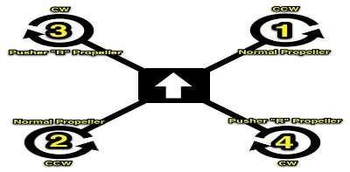

Figure (1) schematic diagram of quadcopter

**Quadcopter flight dynamics [3]**

Quadcopter operates within two frames of reference. First is its own frame of reference which is termed as body frame whereas the second is measured relative to world frame of reference which is termed as inertial frame. In case of body frame, the rotor axes are pointing in positive z direction with the arms pointing in x and y directions (Fig 2) while in case of inertial frame, the gravity pointing in the negative z direction (Fig 3).

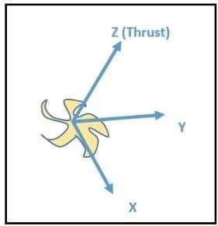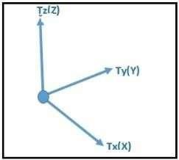

**Fig.3. Inertial frame**

**Fig. 2. Body frame**

Quadcopter is lifted up high in the air with the help of propellers. These propellers convert rotational motion

into thrust and this can be explained with the help of Bernoulli’s principle and Newton’s third

law. Every action has equal and opposite reaction.

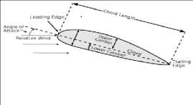

Fig.4 . Air foil

1) *Bernoulli’s principle:* Bernoulli’s principle states that for an inviscid flow of no conducting fluid, and increase in the speed of fluid occurs simultaneously with a decrease in pressure or a decrease in the fluid’s potential energy.

2) *Newton’s third law:*An air foil is the shape of the wing or blade as seen in the cross section, when moved through a fluid produces an aerodynamic force. Due to airfoil shape of the propeller, the air moves faster over the top than under the bottom which results in a greater pressure difference below the airfoil than above it. This pressure difference in turn produces the required thrust.

**Thrust Calculations [10]**

The force normal to the propellers required for providing motion to the Quadcopter is termed as thrust. This

force is generated with the help of rotors which spin at a certain angular velocity. In general, the thrust generated by a

particular rotor is,

|  |
| --- |
| T=ρAVr2 |

Where, ρ = real time air density of air (Kg/m3)

A = Cross sectional area of the propellers.

Vr = Instantaneous peripheral velocity of rotors

(r=1, 2, 3...) = r*w (m/s)

***Take-off and Landing mode***

During takeoff mode, the quadcopter undergoes a translational motion about the positive z axis of inertial frame whereas during the landing mode, the quadcopter undergoes a translational motion about the negative z axis of inertial frame. This is done with the help of throttle given via radio transmitter in which the microcontroller automatically increases or

decreases the speed of rotors in such a way that the motion occurs only along the z axis of the inertial frame. The thrust generated in this case is given by,

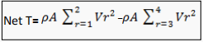

**Hovering**

Hovering is termed as the state of constant altitude maintained by quadcopter. This is possible only when the net thrust exerted on the frame of quadcopter is zero. For the net thrust to be equal to zero, the pair of rotors along x axis should spin at equal speed and opposite direction with respect to the pair of rotors along y axis.

From above equation, Net T=0

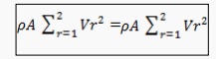

It is important to note that net tangential acceleration in take off, landing and hovering mode is zero which restricts its translational motion along x and y axes respectively

**3.4 Low-Cost Microcontroller-based Hover Control Design of a Quadcopter [10]**

The hover stability of a quadcopter is important for many of its applications such as security surveillance, crop monitoring and on-board imaging to allow clear still images to be taken in surveillance operations [11]. It also prevents the quadcopter from crashing in the event of strong wind or due to its weight. Fig. 1 shows the six degrees of freedom of the quadcopter. In Fig. 5(a), x and y represents the translational motion along the x- and y-axes respectively and represents yaw, the rotational motion about the z-axis, while in Fig. 5(b), represents roll, the rotational motion about the x-axis, represents pitch, the rotational motion about the y-axis and z represents the translational motion in the direction perpendicular to ground. The label ‘1’ signifies the front propeller.

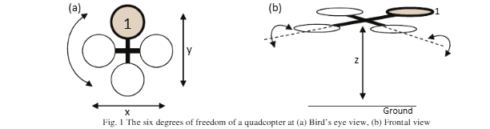



With a hover control unit, the quadcopter will hover at a constant height z (see Fig. 1(b)), with its roll and pitch angles stabilised by the gyroscope. The person at the command base will only need to control the quadcopter’s motion along the x- and y-axes and also its rotation about the z-axis (to turn corners), reducing the degree of complexity from six to only three. This defines the purpose and aim of this paper, which is to obtain a stable quadcopter hover that will last for at least 5 minutes with an acceptable error of within of the hover altitude.

2. Hover Control System Design:

The hover control system consists of three major subsystems: quadcopter, sensor and microcontroller. The quadcopter subsystem forms the physical system that requires control while the sensor subsystem provides altitude information to the control system. The microcontroller subsystem combines the electronic signals with the hardware in the hover control routine, thus achieving automatic hover control. 2.1. Quadcopter subsystem The quadcopter model used in this research is the GAUI 330-X Quadflyer. The quadcopter subsystem consists of a receiver module, a gyroscope unit, electronic speed controller (ESC) circuits, propeller DC motors and a Lithium-Polymer battery. Fig.2 shows the components of the quadcopter subsystem. The command signal is a pulse-width modulated (PWM) signal that is received by the receiver module. The gyroscope unit will modify this signal by incorporating the attitude (roll, pitch and yaw angles) information before transmitting the signal to the ESC circuits. This modification is performed to keep the quadcopter’s chassis level with respect to ground. The ESC modules functions to smoothen the speed variation of the DC motors.

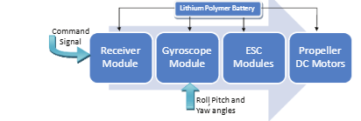

Fig. 6 Components in the Quadcopter Subsystem

**3.5 Product Subsystems and Components**

The following components were included in the design of the drone:

1. Emax XA2212 1400KV 3S Brushless Motor

**2212 1400KV Brushless Motor**  
is a motor that you can use in Quadcopter projects, Fixed-wing model aircraft and many robotic applications.  
Brushless motors have long life and high efficiency. Compatible with 2S- [3S Lipo batteries.](https://robolinkmarket.com/111v-3s-lipo-batarya-6000mah-25c)

* KV: 1400KV
* Working voltage: 2-3S (7V-12.6V)
* Vibration-free operation
* Suitable propellers: 8x4 , 8x6
* Suitable ESC: 25A or above Brushless
* Shaft diameter: 3mm
* Shaft length: 11.7mm
* Weight: 49g

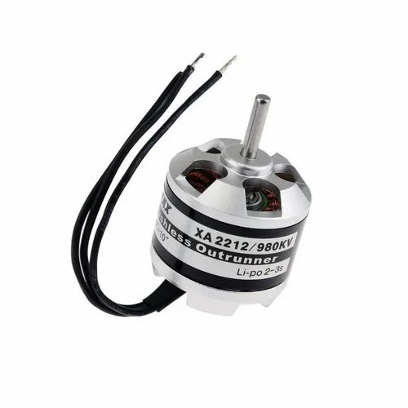

Figure[7]: Emax XA2212

1400KV 3S Brushless Motor

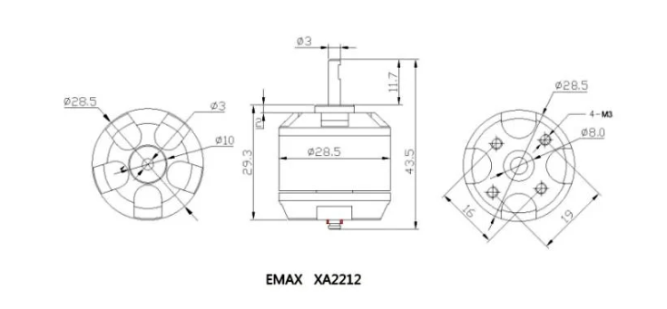

figure[8]: Emax XA2212 1400KV 3S Brushless Motor dimensions

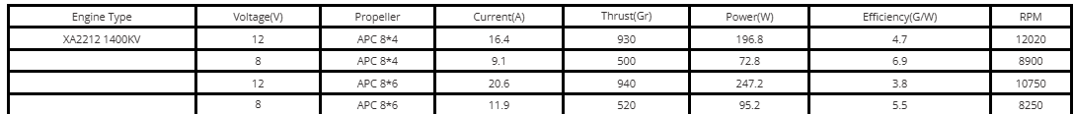

Table [1] explains the pwer for each voltage given

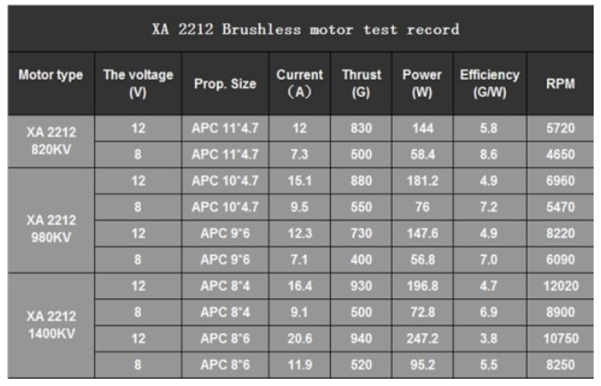

Table[2] : shows the difference between the motor having 820KV,980KV, and the one available in the project 1400KV

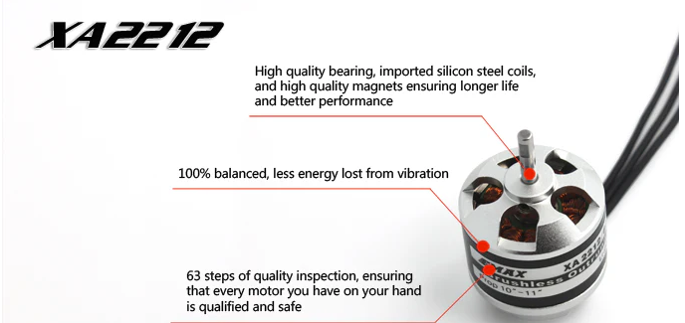

FIGURE[9]: Emax XA2212 1400KV 3S Brushless Mot

1. PROPELLERS

These are simply fans that convert the motion of the motor into upward thrust.

They are, made up of flexible fiber to be unbreakable during crash landing

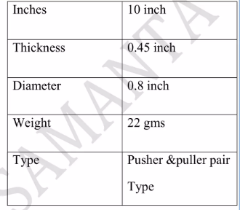

Table [3]: propellers properties

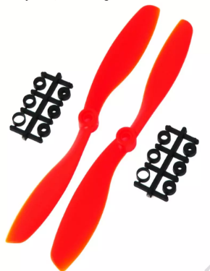

Figure[10]: propellers

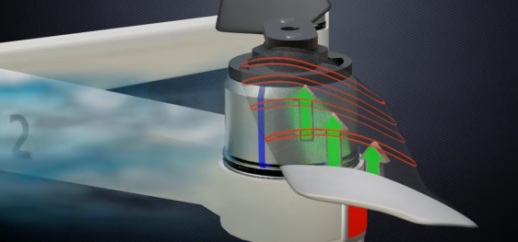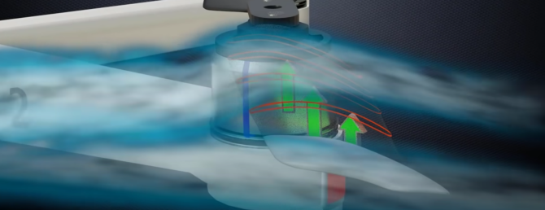

Figure[11]: Airfoil shape the propeller utilize to generate lift force

3. BRUSHLESS 30 ESC 2-65 LIPO

Features:

1, Specifically optimized firmware ESC, the ESC has a very good compatibility;

2, Highly intelligent, adaptive ability, extremely easy to use;

3, Throttle signal line is a twisted pair, copper wire to reduce crosstalk signal generated 4,Supports up to 621Hz refresh rates up to the throttle signal, compatible with a variety of flight control (Note: More than 500Hz signal of the throttle throttle are all non-standard signal)

5, Use MOSFET special driver chip, performance and stability far beyond the driving circuit with discrete components built

ESC Specification:

Cont. Current: 30A

Max. Current: 40A

BEC : No (OPTO ESC)

Li-ion/Li0poly:2-6S

Weight: 28.5g(with banana connector); 30g(without banana connector)

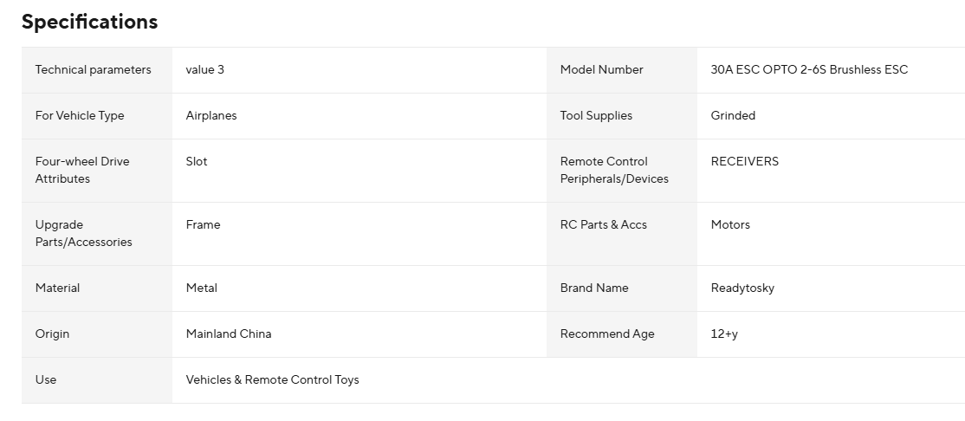

Table [4]: 30A ESC spesification

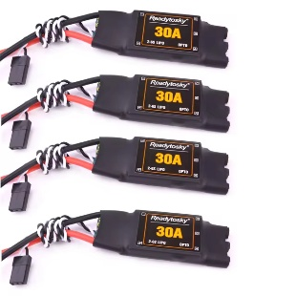

Figure[12]: BRUSHLESS 30 ESC 2-65 LIPO

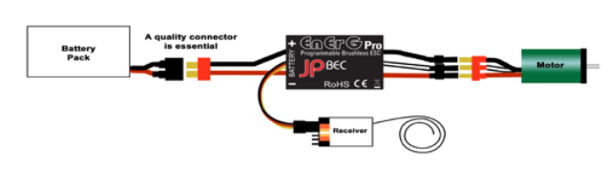

Figure[13] : The connection between A single motor and the battery

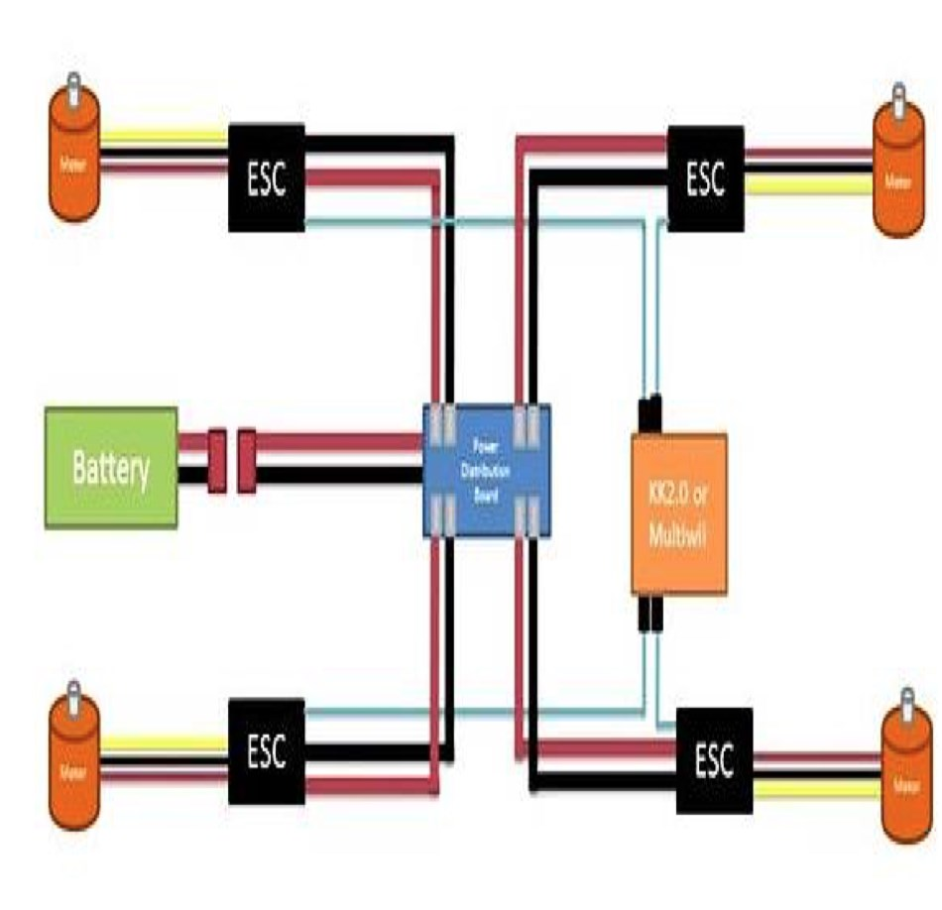

1. Transmitter and receiver :

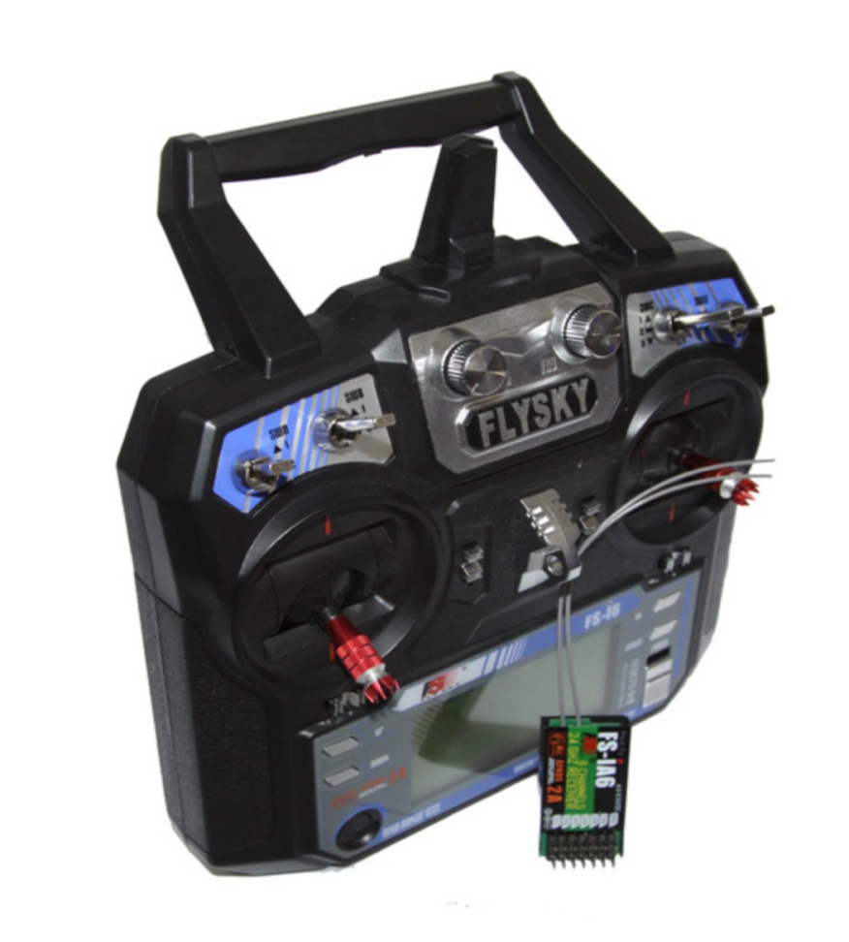

Figure [14]: Tranmitter and receiver used in the project

Transmitter and Receiver System: FlySky FS-i6 and FS-iA6

The drone’s manual control system is based on the FlySky FS-i6 transmitter and FS-iA6 receiver, both operating on the 2.4GHz AFHDS 2A protocol. This system offers 6 configurable channels, with support for various aircraft types including fixed-wing, gliders, and multirotors.

The transmitter features:

* A dual-antenna design for improved signal stability and coverage across 142 frequency bands.
* Low power consumption and a unique transmitter ID to prevent interference from other nearby controllers.
* Memory for up to 20 model profiles and basic telemetry support via its transflective LCD display.

The receiver is compact and lightweight (6.4g), supporting a voltage input range of 4.0–6.5V and delivering reliable signal reception with a sensitivity of -105dBm.

This system was chosen due to its long-range capability, signal hopping for interference reduction, and ease of integration with standard flight controllers.

PPM Encoder

To simplify signal management between the receiver and the Pixhawk 2.4.8 flight controller, a PPM encoder was used. This device converts multiple PWM channel signals from the receiver into a single PPM signal, allowing cleaner wiring and easier configuration.

Key features:

* Plug-and-play setup with preloaded firmware, requiring no additional configuration for basic use.
* Support for up to 8 channels, with options to invert the signal or configure fail-safe behavior.
* Enhanced compatibility with flight controllers and autopilot systems, ensuring reliable data transfer and simplified setup.

The PPM encoder allows to encode up to 8 PWM (pulse width modulated) signals into one PPM (pulse position modulation) signal.

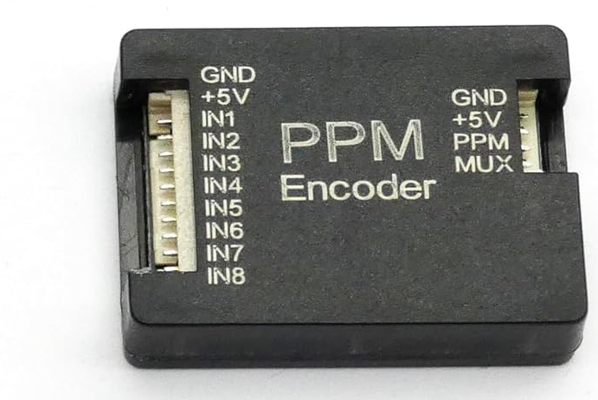

Figure[15] : ppm encoder

1. **Flight Controller and Navigation System**

The UAV's control and navigation system is built around the **Pixhawk 2.4.8 flight controller**, a powerful open-source hardware platform developed from the ArduPilot Mega (APM) and PX4 flight stack ecosystems. Pixhawk supports a wide range of autonomous vehicle types—including multirotors, fixed-wing aircraft, boats, and ground vehicles—offering advanced autopilot functionality through GPS waypoint navigation, telemetry, and sensor integration.

**Key Features of the Pixhawk 2.4.8:**

* Advanced **32-bit ARM Cortex-M4 processor** running NuttX real-time operating system (RTOS)
* **14 PWM/servo outputs**, supporting multirotor and fixed-wing configurations
* Multiple communication interfaces: **UART, I2C, SPI, CAN**
* Integrated **failsafe co-processor** (STM32F103)
* Internal sensors: L3GD20H 16-bit gyroscope and X4HBA 303H 14-bit accelerometer/magnetometer
* **168 MHz processing speed**, 128 KB RAM, 2 MB flash memory

This flight controller was mounted using a **glass fiber anti-vibration absorber frame**, isolating the unit from motor-induced vibrations to improve sensor accuracy during flight. The damping system includes dual fiber-reinforced plates with rubber shock absorbers, sized to fit most common controller units (APM, KK, Pixhawk).

**GPS Module: Ublox NEO-M8N**

To enable autonomous navigation and flight stability, the Pixhawk is paired with the **Ublox NEO-M8N GPS module**, which supports multiple satellite systems including GPS, GLONASS, BeiDou, and QZSS. This enhances positioning accuracy and reduces lock-on time under variable conditions.

**NEO-M8N GPS Specifications:**

* **72-channel** GNSS engine, supporting up to 10 Hz update rate with multi-GNSS
* Positioning accuracy: **±2.0 meters**
* Sensitivity: up to **–167 dBm**
* Supports **AssistNow Online and Offline GNSS** for faster acquisition
* Compatible with **OMA SUPL and 3GPP standards**
* Built-in odometer for distance tracking
* Flash memory for quick startup and GPS retention

The module was mounted on a lightweight GPS holder (140mm rod, 20g total weight), placed away from high-current wires to reduce electromagnetic interference and ensure reliable signal acquisition.

**Power Module**

A standard Pixhawk-compatible **power module** is used to monitor voltage and current while supplying regulated power to the flight controller.

**Power Module Features:**

* Maximum input voltage: **28V**
* Current sensing up to **90A**
* Integrated **switching regulator** outputting **5.3V at 3A**
* Plugs directly into Pixhawk's PM port via a 6-pin DF13 connector
* Compatible with up to **6S Li-Po** batteries

This module allows real-time battery monitoring and system status feedback via telemetry, helping to prevent in-flight brownouts and improve mission reliability.

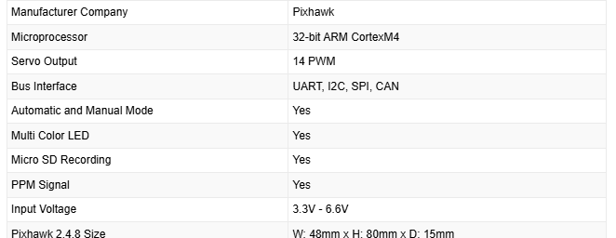

Table[5]: specification tabled

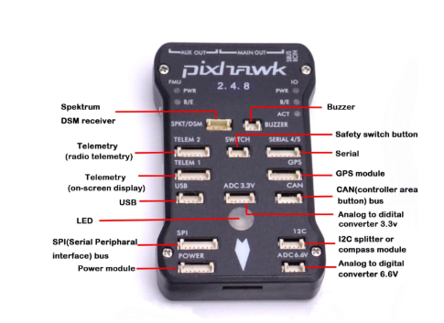

Figure [16]: Pixhawk 2.4.8 shape and parts

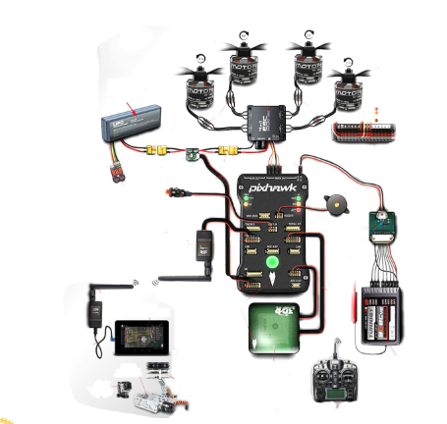

Figure 17: full diagram with the Pixhawk 2.4.8

1. F4V3SM8N GPS LC Betaflight Flight Controller Board - M8N GPS

F4V3SM8N GPS LC Betaflight Flight Control Board is a board created by combining a series of sensors such as a gyroscope, magnetometer, and accelerometer with GPS and you can control all the movements of the drone. Flight control CPUs can use data about all states, including the drone's state, speed, position, and direction, to guide the flight and operation of the vehicle according to the parameters.

**F4V3SM8N GPS LC Betaflight Flight Controller Technical Specifications:**

* Microprocessor: STM32 F405 MCU
* Internal Current
* VTX PID Programming with smart sound
* D-Shot Supported
* SD CARD Slot for BlackBox
* MPU6000
* OSD
* Signal Pin Hole: 4 x
* Pin hole for ESCs: 4 x 3
* SBUS/PPM + DSMX Ports
* SmartAudio V2
* IR pins

**GPS Module Technical Specifications:**

* Material: Plastic
* Tracking Sensitivity: -161dBm
* Capture Sensitivity: -148dBm
* Capture Time: 0.1s (average)
* Cold Start Time: 38s (average)
* Hot Start Time: 35s (average)
* Simultaneous GNSS: 10Hz
* Power Supply Voltage: 3.5V / 5.5V
* Temperature: 40°C / 80°C
* Dimension: 55 mm

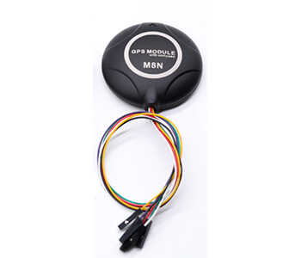

Figure[18]: F4V3SM8N GPS LC Betaflight Flight Controller Board - M8N GPS

1. Battery

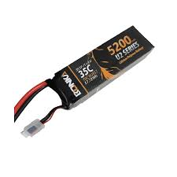

Figure[19]11.1V / 5200mAh Li-Po battery

The GenX Power Premium Lipo batteries are the gold standard for performance in the High Discharge Lipo Battery Segment. The 5200 mah Batttery is a 40C discharge rating cell which has a burst current of upto 80C. With the best energy density and weight to energy ratio available in the market, the GenX Power Premium Lipo Batteries are the most compact cells in the segment and stand out from the other available batteries.

The GenX Power Premium 11.1V 3S 5200mAh 40C Lipo Battery with XT60 Connector is a 3s1p battery pack with a nominal Voltage of 11.1V. This battery pack has 3 cells connected in series with a capacity of 40C continuous discharge. The nominal capacity of the battery pack is 5200mah.

Each battery pack is made with matched impedance cells to provide the maximum usable time after each charge. This battery is guaranteed for performance in professional drones, agricultural drones and other demanding multi-rotor and fixed wing aircrafts.

Features

* Each battery pack is made with impedance matched cells for maximum performance
* Most compact and minimum weight for the capacity
* Higher number of life cycles than other cells.

Specifications(12)

|  |  |
| --- | --- |
| Capacity | 5200 mah |
| Nominal Voltage | 11.1V |
| Configuration | 3S1P (3 cells in Series) |
| Discharge Rate | 40C |
| Max Burst discharge Rate | 80C |
| Net Weight(±2%) | 420g |
| Dimensions | 140mm x 45mm x 32mm |

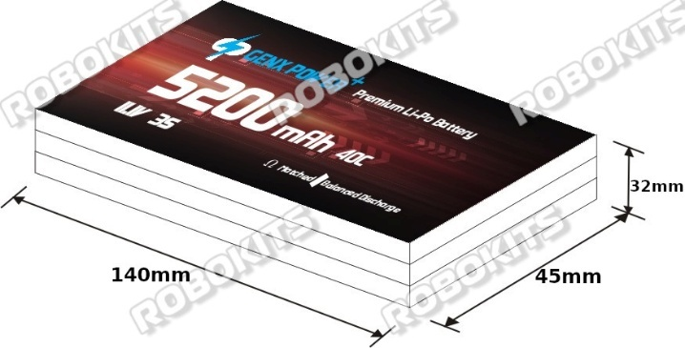

Figure[20]11.1V / 5200mAh Li-Po battery dimensions

1. Lastly the frame

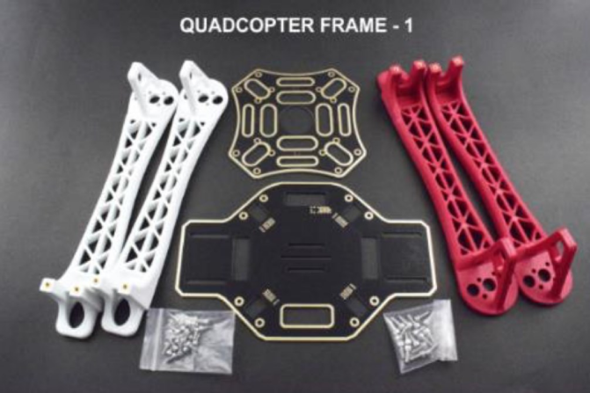

Figure[21]: the frame

The head of the frame bot broken so I switched the head to a simple board.

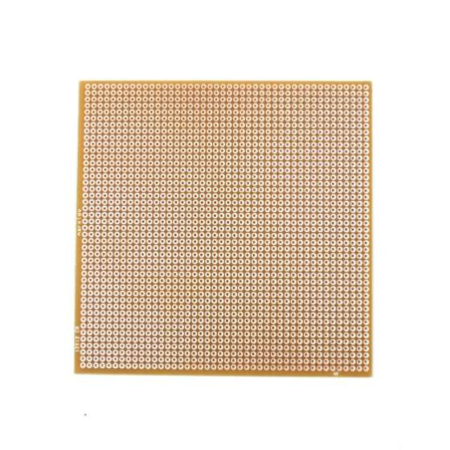

Figure[22] the board

**Color**: White & Red & Black

Frame arm size: 21.5 * 3.8 * 5cm / 8.5 * 1.6 * 2.0inch

Weight: 43g(Single)

Weight: 250g / 4pcs

**Features**:

The DJI F450 Flame Wheel frame arms are built from very strong materials, these

arms are made from the ultra-strong PA66+30GF material which provides better

resistance to damage on hard landings.

Specification:

**Color**: Black

Material: Fiber Glass & Plastic

**Package Includes**:

Flame Wheel(2 Red,2 White) x4

F450 TOP Plate x1

F450 BOTTOM Plate x1

F-M3*8 Screws x16

F-M2.5*8 Screws x24

**3.6 Design Implementation**

The assembly and integration of the UAV quadcopter were carried out in stages to ensure that each subsystem—mechanical, electrical, and software—functioned correctly before full system integration. Due to limitations in component availability and time, the design focused on practical implementation using pre-supplied parts, with several custom adaptations made during the build process.

**3.6.1 Frame Assembly and Mounting**

The quadcopter's X-frame was assembled using a DJI F450-style base. Brushless motors were mounted on each arm with alternating rotational direction to balance torque. The central plate was modified to accommodate a custom-built head, using a repurposed prototyping board for mounting the Pixhawk 2.4.8 flight controller. This board was secured using screws and vibration-isolating pads to protect onboard sensors.

The GPS module was mounted on a raised bracket to reduce electromagnetic interference from high-current wires and ESCs. The battery was strapped beneath the frame, centered to maintain balance during hover and flight maneuvers.

**3.6.2 Electrical Wiring and Power Management**

Each of the four EMAX XA2212 1400KV brushless motors was connected to a dedicated 30A ESC, which was wired directly to a power distribution board (PDB). A standard 11.1V 5200mAh Li-Po battery was used as the primary power source. The battery was connected to the PDB via a manually adapted XT60 connector, due to damage in the original connector and unavailability of replacements.

The Pixhawk flight controller received regulated power through a dedicated power module, which also handled current and voltage monitoring. Signal connections between the receiver and Pixhawk were made using a PPM encoder to simplify cable management.

**3.6.3 Software Setup and Firmware Configuration**

The Pixhawk was configured using **QGroundControl** and **Mission Planner**. Due to compatibility issues between the Pixhawk 2.4.8 and newer versions of QGroundControl, an older firmware version was installed using Mission Planner. Once compatibility was ensured, the following setup steps were completed:

* Sensor calibration (accelerometer, gyroscope, magnetometer)
* Transmitter channel mapping and fail-safe configuration
* ESC and motor testing (including direction and throttle range)
* GPS setup and position lock verification
* Flight mode configuration (Manual, Stabilize, Loiter)

**3.6.4 System Validation and Dry Testing**

Before live testing, a dry run was conducted to validate the electrical and signal flow. Key checks included:

* Receiver input recognition and response within QGroundControl
* Successful arming of the flight controller after resolving pre-arm errors
* Stable GPS lock with the new M8N module
* Correct motor spin directions and throttle responsiveness

Issues encountered during this phase included poor soldering on two ESCs, unnumbered motor wiring, and voltage misreadings due to firmware mismatch—all of which were corrected through rewiring, firmware rollback, and hardware replacement.

**3.6.5 Final Configuration and Readiness**

After correcting hardware and software issues, the drone was successfully armed and completed its first short hover indoors. Although further tuning and sensor-based flight modes are planned for the next project phase, the current implementation validates the functional integration of all major subsystems.

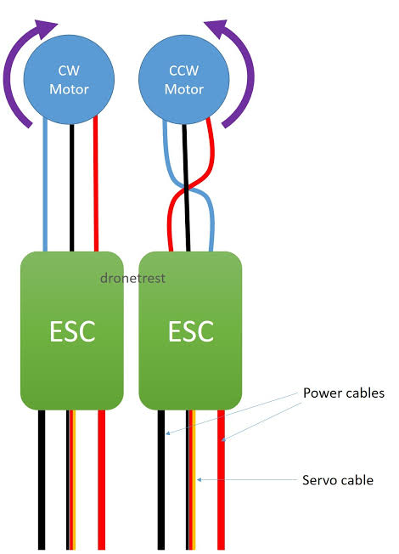

Figure [23]: ESC connection for CW and CCW

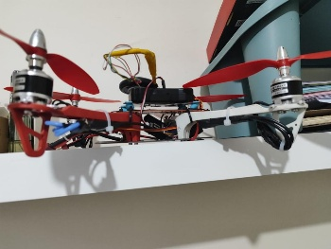

Figure 24: 2 ESCs (in black under the frame) are connected to the motors on the drone.

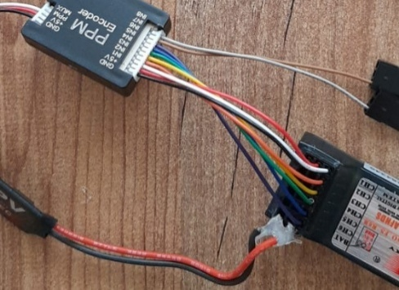

Figure [25]: a transmitter to PPM encoder connection

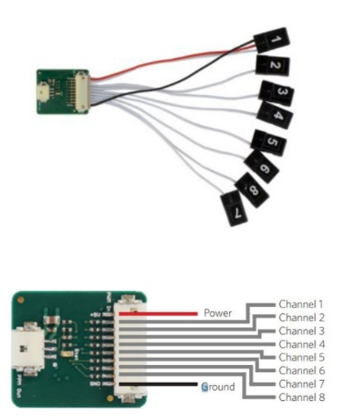

Figure [26]: PPM encoder connection to transmitter channels

**3.7 final design figures**

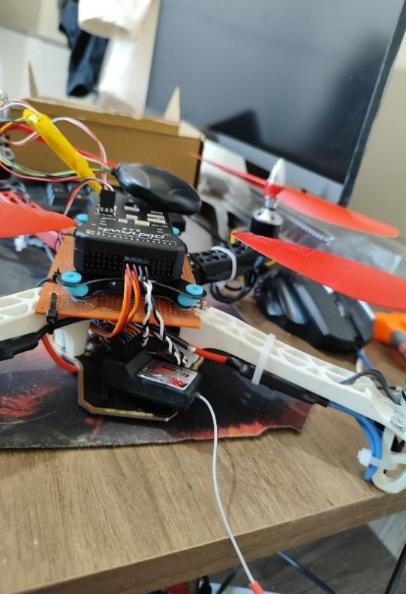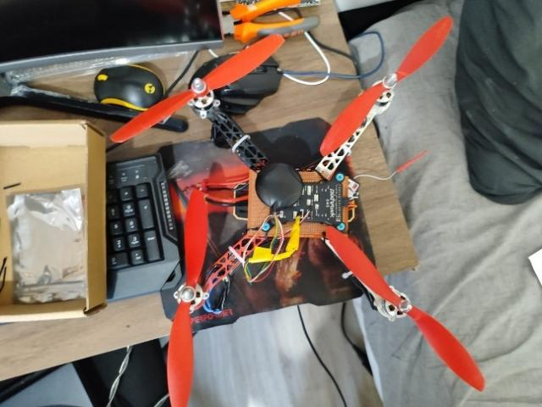

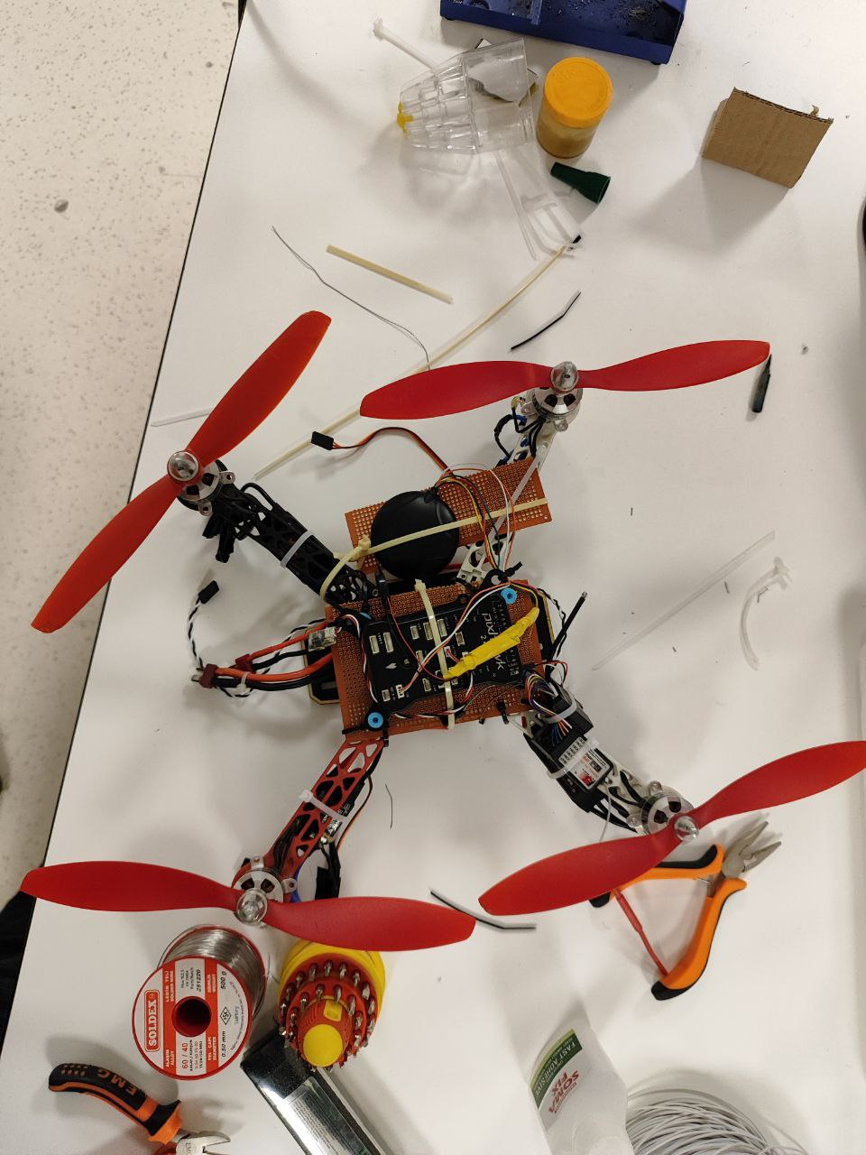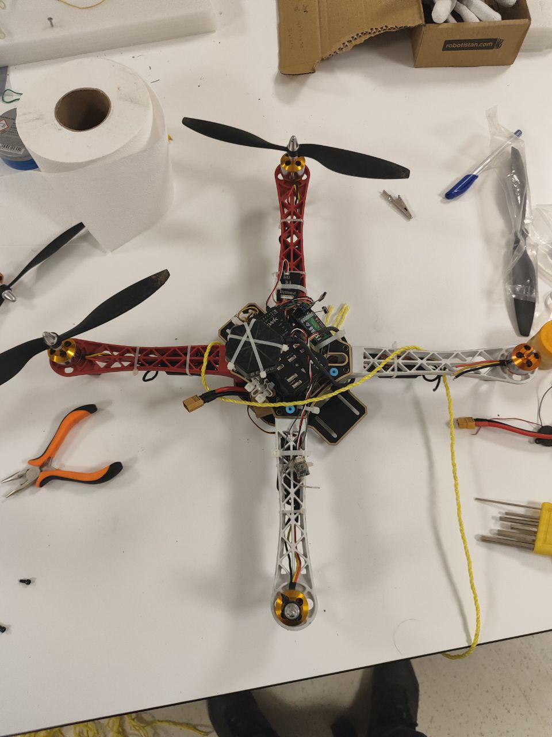

Figures 27 to 31 are figures after assembling.

**Section 4**

**System Testing and Analysis**

**4.1 QGroundControl**

Installed QGroundControl to setup the drone I built by following these steps:

1. This is the background after opening the app

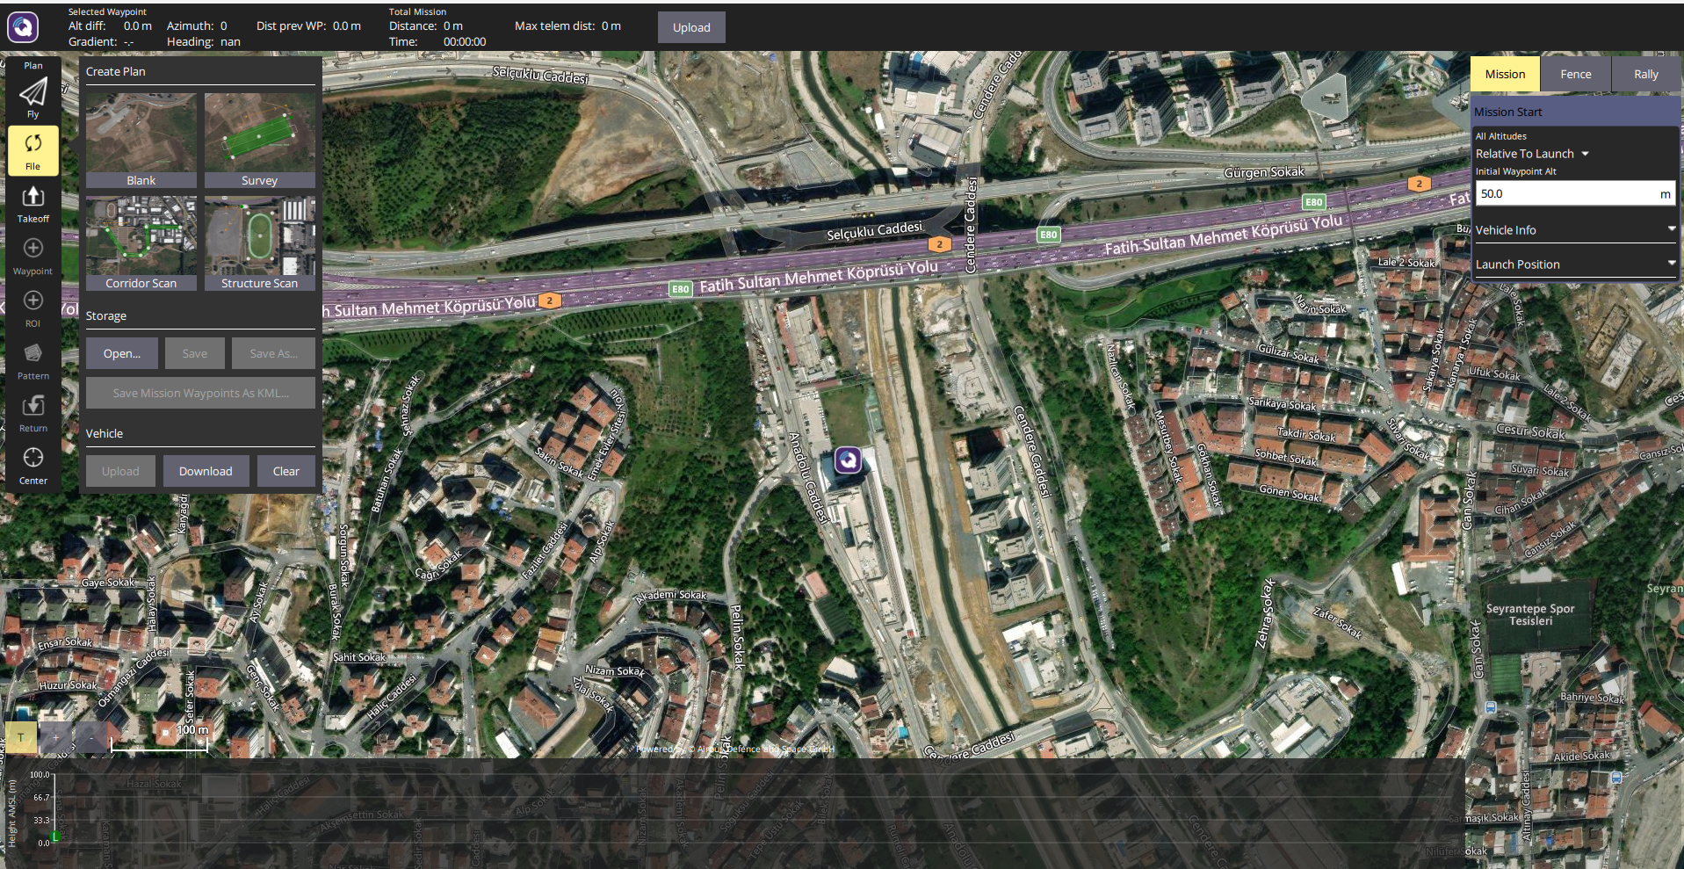

**figure(32): qground control background**

1. We access vehicle setup

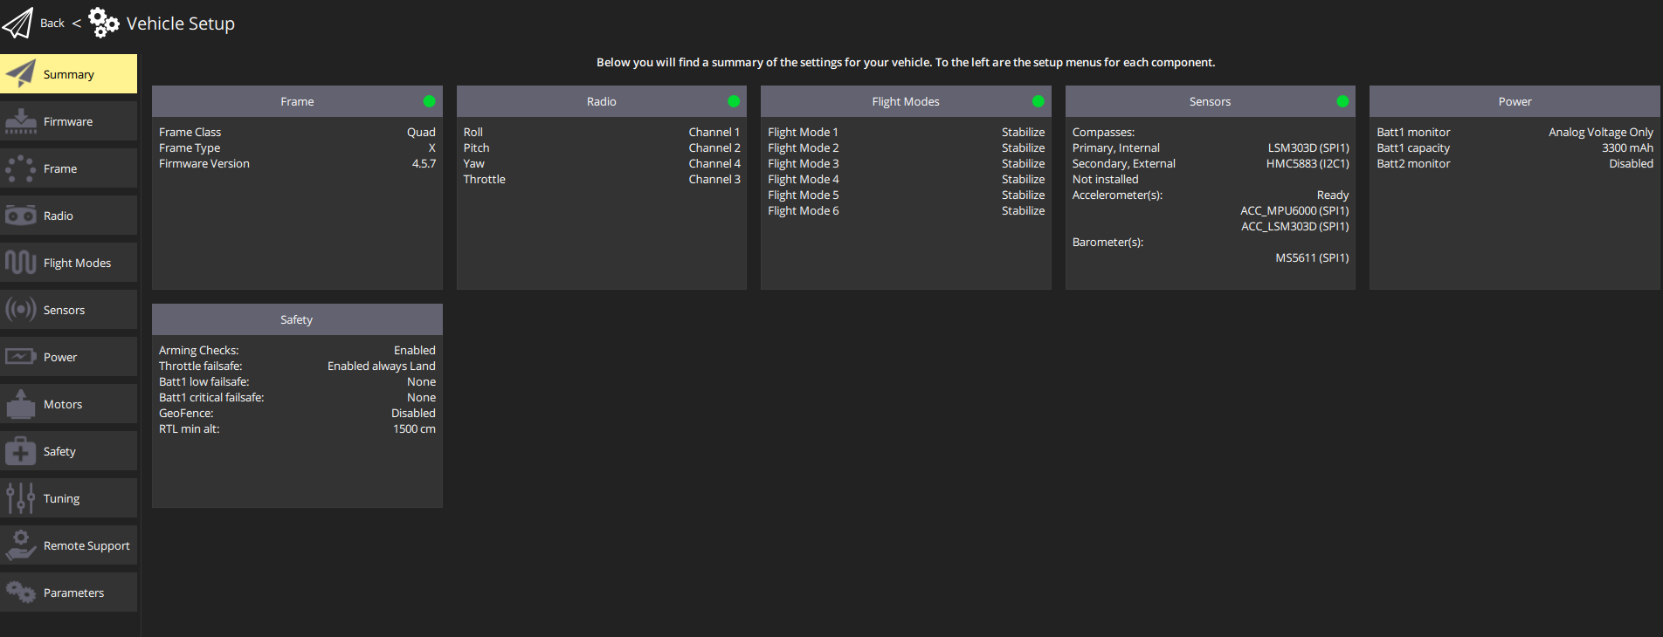

Figure(33): drone setup

There are 12 setups on the left.

Starting with the summary in the previous picture, we can see the important setups that allow the drone to fly, if it has green light dot then the selected setup is good to go.

1. Install/ update firmware by disconnecting/ connecting the usb

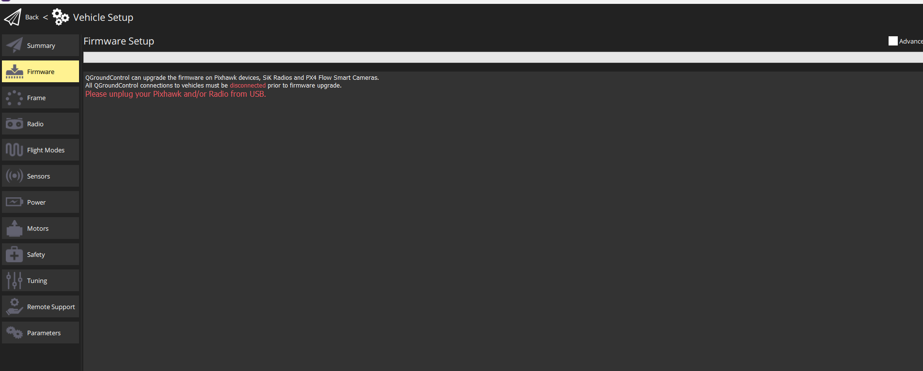

Figure(34): firmware

1. Choose the correct drone frame

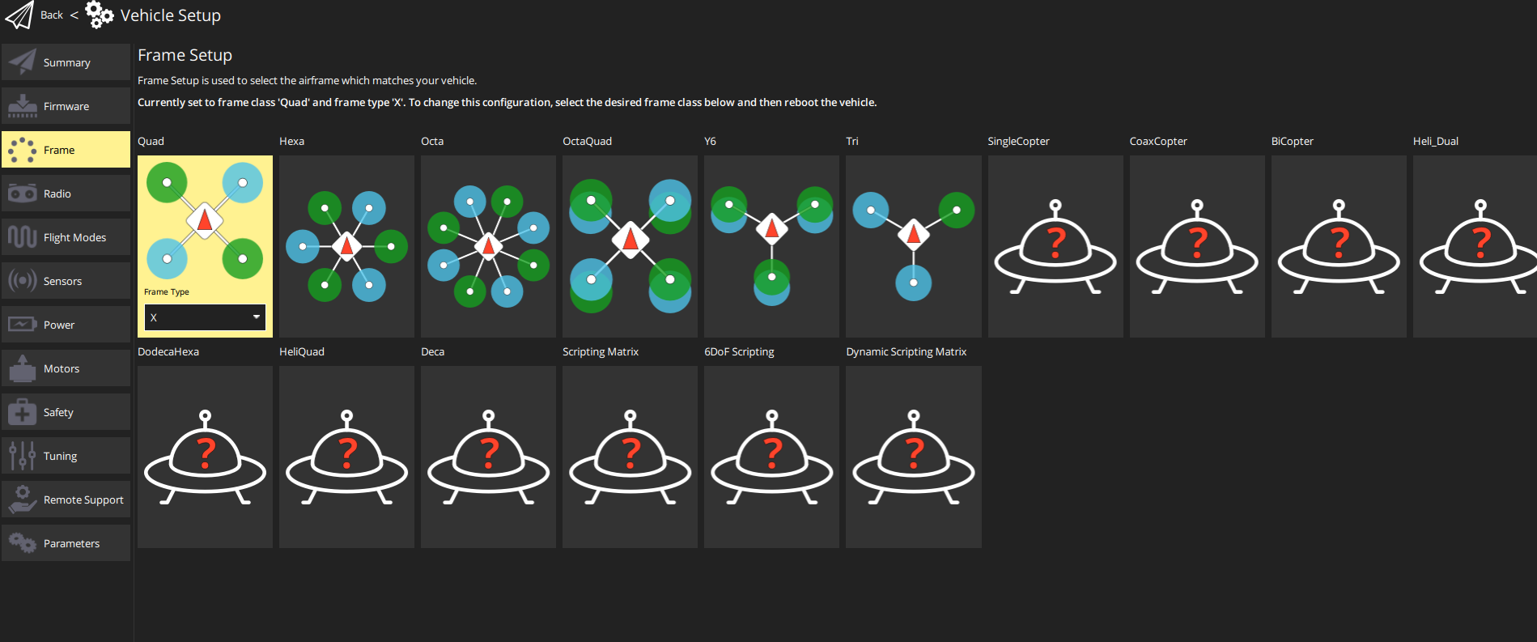

Figure(35): frame

1. Collaborate the transmitter to the receiver and take control of the drone by applying all steps in order for the controller to function and control the drone then choose the flight mode or skip.

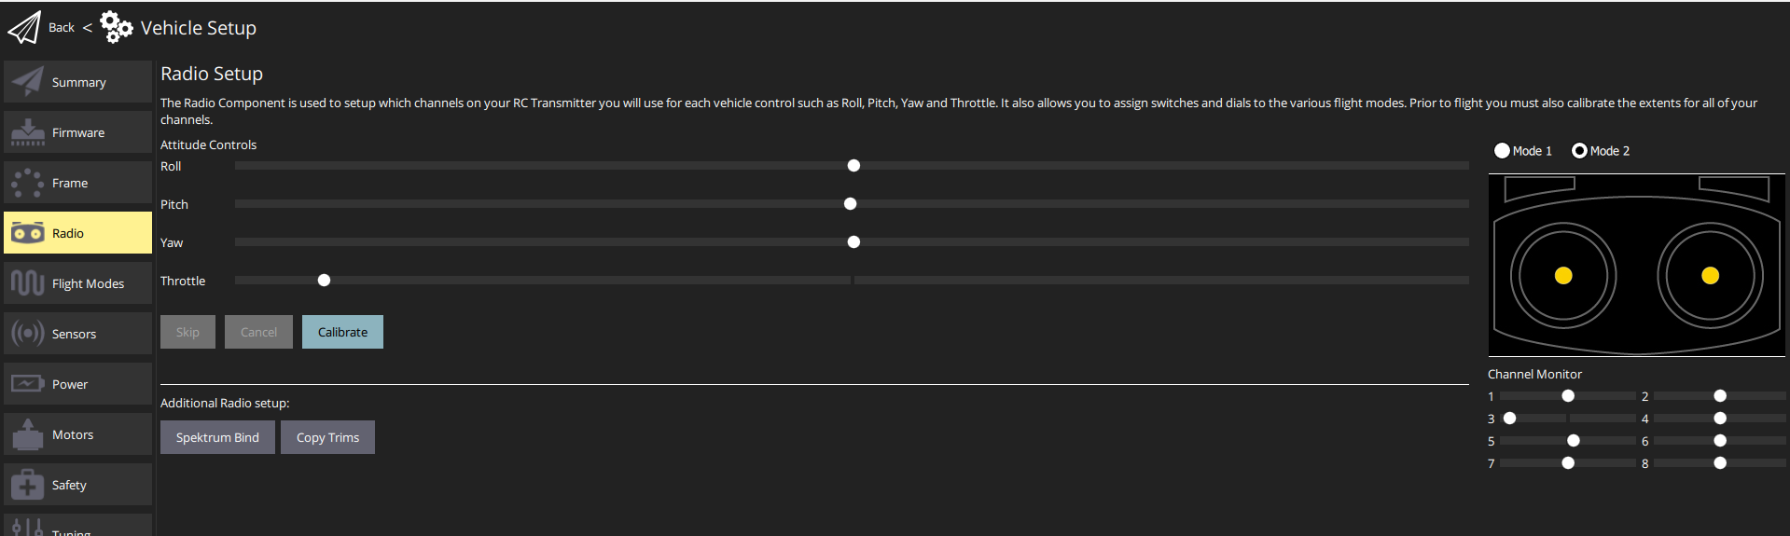

Figure(36): radio

1. Calibrate all the following sensors so that you can control the drone flawlessly

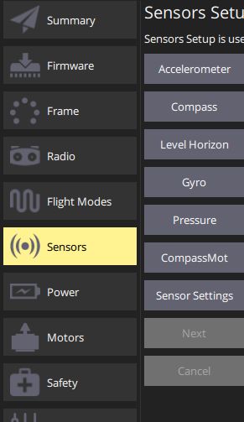

Figure(37): sensors

1. Continue the remaining setups
   1. **Test phases**

**Test Phase 1: Initial Attempt - Hardware Complete, Arming Failed**

After completing the hardware assembly, the first flight attempt was unsuccessful due to two major issues:

* Battery malfunction: The voltage reading remained abnormally low.
* GPS lock failure: The GPS could not establish a stable connection, preventing the flight controller from arming.

These problems made it impossible to initiate takeoff. The resolution steps for these issues are explained in Section 4.3, parts 3 and 5.

**Test Phase 2: Arming Achieved - Motor Imbalance and Instability**

Once the firmware and GPS issues were resolved, the drone was successfully armed. As a safety measure, a rope was tightly secured to the frame to prevent uncontrolled flight.

However, during the test:

* Three motors operated at lower speeds than the fourth, due to an incorrect setup.
* This imbalance caused the drone to flip repeatedly (over six times).
* The final flip caused minor damage to one propeller.

This phase was not considered successful, but it helped identify a critical configuration issue in motor output calibration.

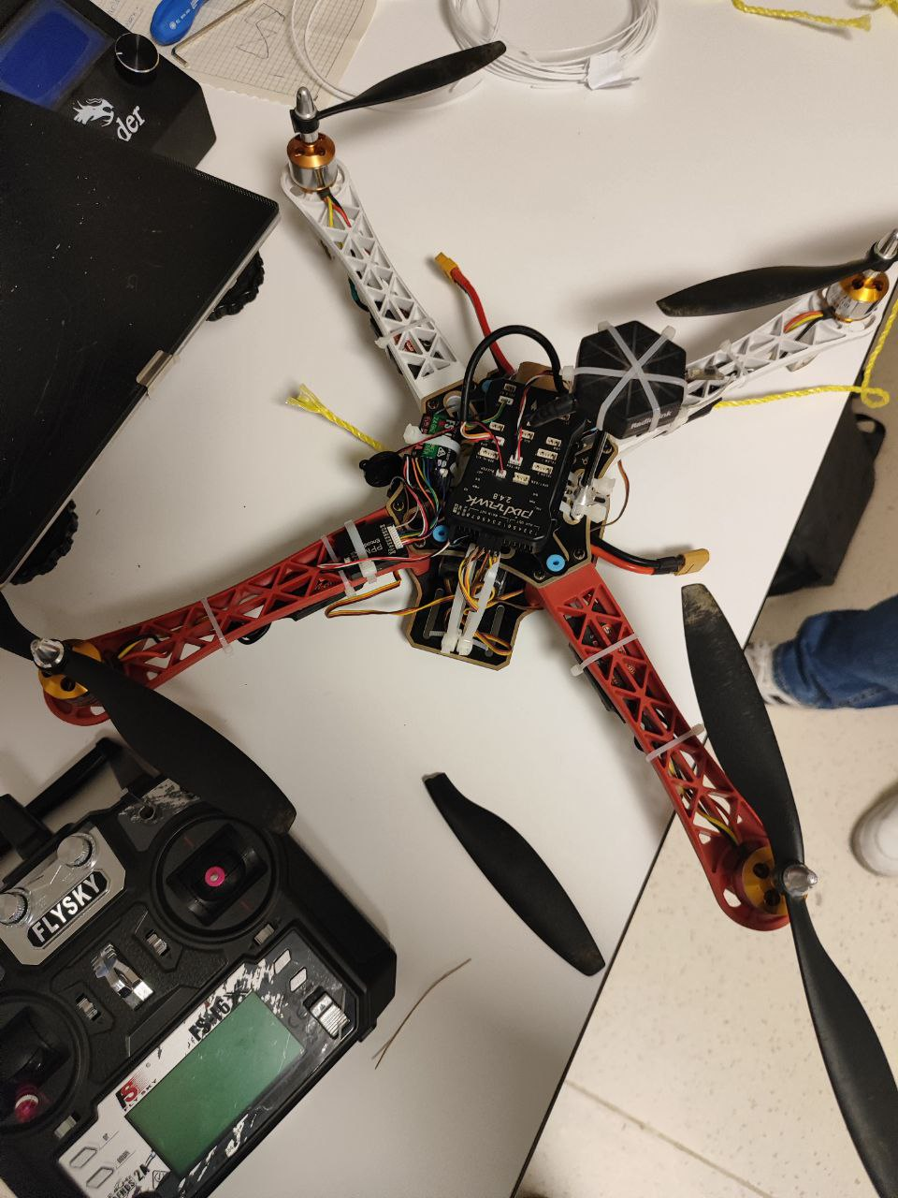Figure(38): broken propeller after phase 2

**Test Phase 3: Autonomous Takeoff Attempt - Severe Failure Due to Mismatched Motor KV Ratings:**

In this phase, I attempted to execute autonomous takeoff and landing using QGroundControl. The drone was connected via USB to my laptop and powered by the main battery.

Upon pressing the "Takeoff" command:

* The drone immediately lost control, struck the laptop, and damaged its frame.
* It then collided with me, causing a minor injury.
* Severe hardware damage occurred:
  + 3 out of 4 motors were destroyed.
  + All four propellers were broken.

After further inspection, I discovered the root cause of the crash:

* One motor had a KV rating of 1800, while the other three had KV ratings of 1400.
* This difference caused a severe imbalance in thrust, making stable flight impossible.
* The mismatch went unnoticed during earlier testing because I had been told all motors were identical when they were provided to me.

As a result of this failure, I had to:

* Replace all four motors to ensure uniform KV ratings.
* Re-solder each motor to its ESC.
* Test each new motor individually to confirm consistent output and direction.

This phase resulted in a one-week delay but provided a crucial lesson in verifying all component specifications, even when parts are pre-supplied.

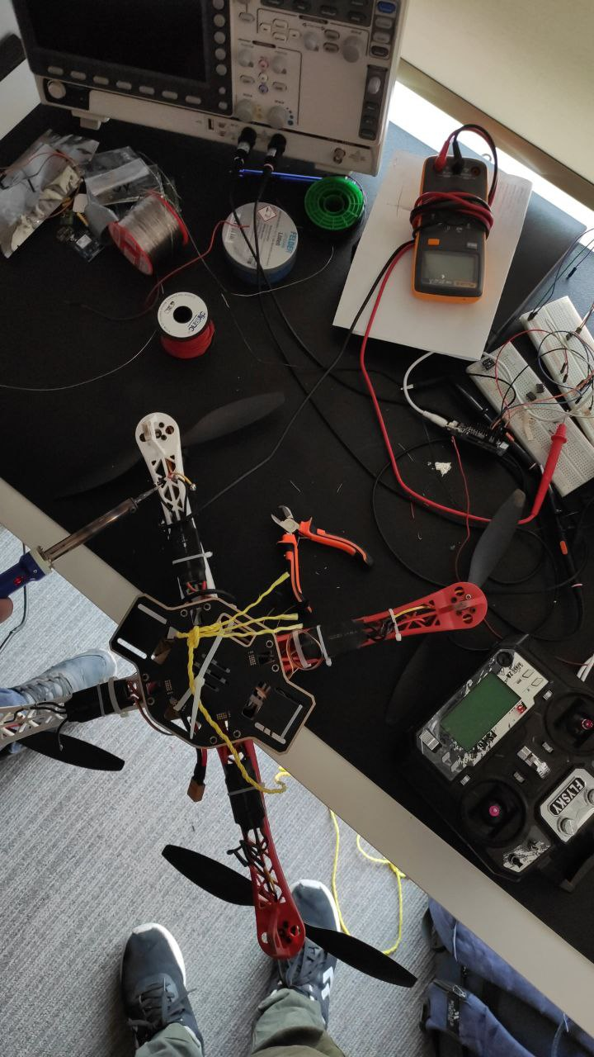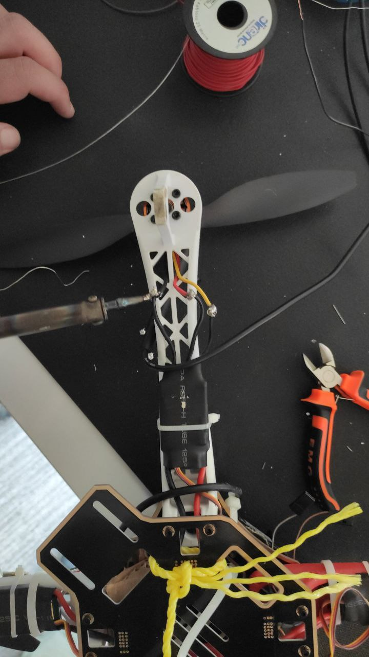

Figure(39-40): resoldering damaged motors to ESCs

**Test Phase 4: Successful Flight Test**

After completing the repairs and learning from previous mistakes, the final test was conducted in a safe, open area on the university campus.

* A rope was once again tied to the frame for control, and a friend assisted by holding the rope and filming the process.
* The drone achieved a successful 20-second flight and stable landing.
* It reached an approximate altitude of 15 meters.
* The flight was smooth, and no mechanical issues occurred.

This marked the first successful test flight, confirming that the drone was fully functional and flight-ready.

**4.3 Events/ challenges while working on the drone**

As with any technical project, various challenges and errors were encountered throughout the development process. One of the most significant issues I faced is outlined below:

1. **Building a New Head for the Frame**

As previously mentioned, the drone components and parts were provided to me before the project began. However, the frame was incomplete—it lacked the head section, which is essential for securely mounting the flight controller and various sensors.

To overcome this issue, I had to find an alternative method to ensure the stability of these critical components during flight. I decided to repurpose a small orange board that I had previously used to stabilize an ESP32 microcontroller in another project. This board served as a makeshift head for the drone frame, providing a stable platform to mount the flight controller and sensors securely.

The implemented solution is shown in the figure below.

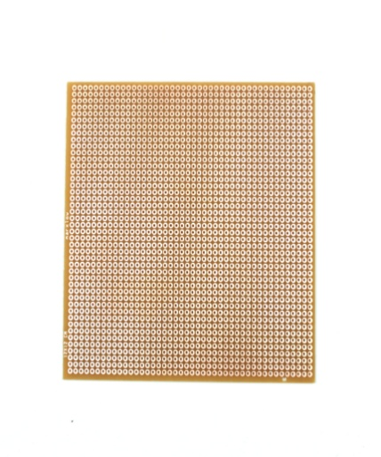 

Figure[41] the board

Figure[42] final look

2. **Soldering Error**

During the assembly process, I encountered a significant issue related to soldering. At the time, the available soldering machine was malfunctioning, so I decided to take the drone to a professional soldering specialist. After explaining the necessary connections, the specialist performed the work in a separate room within his shop. Unfortunately, he did not follow my instructions to number the motors properly.

As a result, the testing phase that followed was disorganized and problematic. During individual motor testing, it became clear that two of the Electronic Speed Controllers (ESCs) were not connected correctly. One motor failed to function entirely, another had erratic behavior, and only one motor operated correctly—amounting to a success rate of roughly 25%, which was unacceptable for flight readiness.

Due to these issues, I had to re-do all the soldering work myself. I spent over 15 hours per day across several days attempting to fix the connections, but due to my limited soldering experience and the approaching project deadline, I decided to switch to a new drone frame that came with all the hardware already assembled. Only the setup remained to be completed. With this decision, the hardware-related challenges were officially resolved.

**3. Pre-Arm Failure and Battery Voltage Error**

Early in the testing phase, I encountered a persistent "Pre-Arm Failed" error, accompanied by an unusually low battery voltage reading. Regardless of the troubleshooting steps I took, the battery voltage consistently displayed around 0.2 V, far below the required minimum of 9.6 V.

To address the issue, I initially attempted to resolve the error using different software. I installed Mission Planner and downloaded the firmware through the application. While this temporarily removed the “Pre-Arm Failed” warning, the battery voltage problem remained unresolved. I tested the battery by charging it fully, replacing it with a new one, and even using it in another project—all of which confirmed that the battery itself was functioning correctly. Despite these efforts, the drone continued to show no response, and the voltage reading did not improve.

After several unsuccessful attempts and days of troubleshooting, I sought assistance from Professor Naim and his assistant Abdelrahman. Together, we thoroughly investigated the issue over multiple sessions. Ultimately, we discovered that the root cause of the problem was a compatibility issue between the Pixhawk 2.4.8 flight controller and the latest versions of the ground control software (QGroundControl and Mission Planner).

To resolve the issue, we installed an older version of the software on the laptop and downloaded compatible firmware for the flight controller. Once the setup was completed using the earlier software version, the drone was finally able to arm successfully, and moments later, it completed its first flight.

**4. Battery Charging Issue**

As mentioned in the previous challenge, the troubleshooting process required multiple rounds of battery testing, which involved charging the battery several times. During one of these charging attempts, the XT60 direct-connect adapter broke, making it impossible to charge the battery in the standard way. The adapter either needed to be replaced or repaired through soldering.

Unfortunately, the soldering equipment available at the time was too large and imprecise for working with a small connector like the XT60. Attempting to purchase a new adapter was also unsuccessful, as local stores only sold the connector components separately and not as a complete unit.

To work around this problem, my friends and I devised a temporary but effective solution. As illustrated in the figure below, we manually connected the positive terminal of the battery to the positive terminal of the adapter, and did the same for the negative terminals. This improvised method allowed the battery to be successfully charged and the testing process to continue.

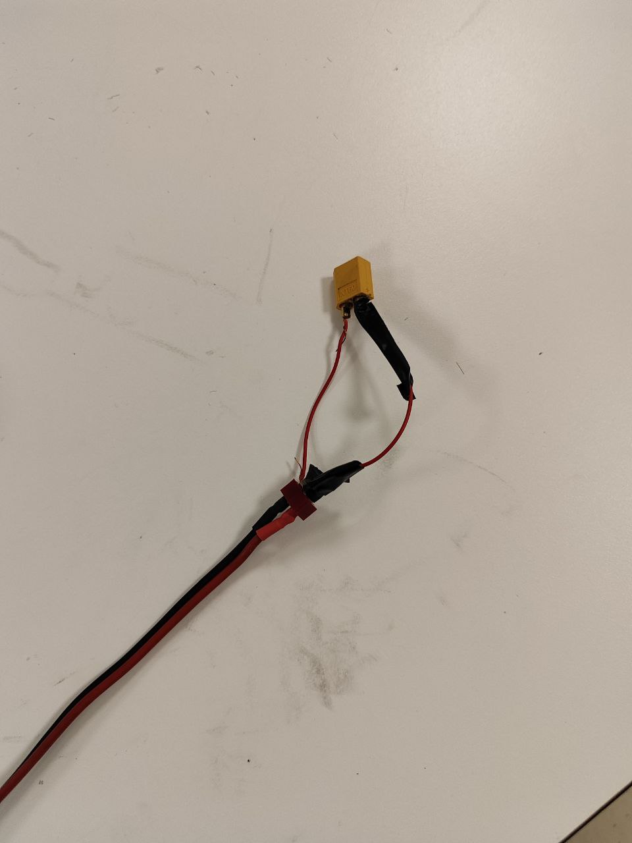 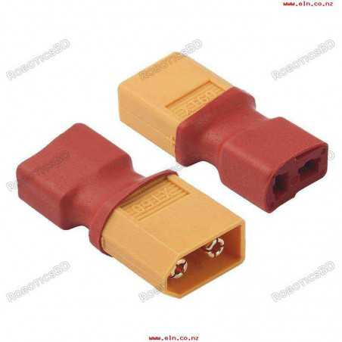

Figure(43): engineered a new way to charge figure(44): XT60 battery adapter

**5. GPS Module Issues**

nitially, I encountered a significant issue with the GPS sensor. Despite numerous attempts over the course of three consecutive days, the sensor consistently failed to provide accurate directional data or establish a stable connection. This malfunction was also one of the contributing factors to the persistent “Pre-Arm Failed” error.

I tested the sensor in various positions and environments, but it did not respond correctly or acquire a proper GPS lock. After exhausting all possible troubleshooting steps, I consulted with my professor, who provided me with a replacement GPS unit. Remarkably, the new sensor established a stable connection and accurate positioning within just a few seconds, resolving the issue completely.

**6. Mismatched Motor KV Ratings Leading to Power Imbalance**

During the third test phase, a critical issue was discovered that caused the drone to lose control and crash violently. Although I was told that all motors were identical when they were given to me, it was later revealed that:

* **One motor had a KV rating of 1800**, while the other three were **1400 KV**.
* This mismatch caused **significant thrust imbalance**, leading the drone to flip uncontrollably upon takeoff.

Because the difference was not visually obvious and I had trusted the information provided, I initially overlooked verifying the motor specifications. This mistake resulted in:

* **Destruction of three motors and all propellers**,
* **Minor physical injury**,
* And a **one-week delay** due to full hardware replacements and re-soldering.

**Lesson learned:** Never assume pre-supplied components are fully compatible. Verifying technical specs individually is essential to prevent performance and safety failures.

1. **Component Inconsistency and Motor Numbering Errors During Initial Assembly:**

Before reaching the first testing phase, I encountered significant hardware issues during the initial build. While soldering the motors to their respective ESCs, I mistakenly misnumbered the motor connections. This error led to incorrect motor assignments, which required me to **redo the entire wiring process from the beginning**.

Additionally, I discovered that the provided components included **two different types of ESCs and two types of motors**, one of which had a different KV rating (1800 KV vs. 1400 KV). To avoid power imbalance and ensure stability, I had to replace all motors and ESCs with matching, compatible units before proceeding to Test Phase 1.

**Conclusion and Discussion**

In conclusion, the drone has so many applications and designs and the drone can be designed using 1 motor,2 motors, 3 motors, 4 motors as used in this project, 6 motors, and 8 motors each number of motors has different applications different than the application mentioned in this report, papers and studies were implemented in the report and got a whole chapter for themselves in some points.

This report presents the design, development, and partial implementation of a UAV quadcopter. The report demonstrates a strong foundation in robotics and software engineering principles, incorporating detailed explanations of the hardware and software components required to build an autonomous drone. By utilizing advanced components such as brushless motors, ESCs, and a Pixhawk 2.4.8 flight controller, the project achieves a functional and scalable framework for further enhancement.

The design process has been methodically documented, from assembling the frame to integrating flight controllers and communication systems. Key technical aspects, including thrust calculations, stability mechanisms, and aerodynamic considerations, are thoroughly addressed, showcasing the application of theoretical knowledge to practical engineering challenges.

However, due to time constraints, the project remains incomplete in terms of testing and final validation. The next semester will focus on completing the integration of cameras and sensors, conducting comprehensive flight tests, and analyzing performance metrics such as stability, load capacity, and battery efficiency. These steps will ensure that the UAV fulfills its intended applications, including surveillance, diagnostics, and other practical use cases.

# 

# References

[1] <https://youtu.be/N_XneaFmOmU?si=HdRtIMhqz6Gkl4Z2>

[2] Senior Design Project Report - Security Quadcopter <https://www.pmu.edu.sa/attachments/academics/pdf/udp/coe/dept/ee/senior%20design%20projects/quadcopter_for_security_report.pdf>

[3] Prof.A.V.Javir, Ketan Pawar, Santosh Dhudum, Nitin Patel, Sushant Patils Design,  
Analysis and Fabrication of Quadcopter JIAATS March 2015 <https://www.researchgate.net/publication/358427077_Design_Analysis_and_Fabrication_of_Quadcopter>

[4] <https://www.intechopen.com/chapters/75241>

[5] Anand SS, and Mathiyazaghan R “Design and Fabrication of Voice Controlled

Unmanned Aerial Vehicle”2016

[6] Akshay Balachandran1, Akshay Shah, Dr Jayaramulu Challa “Propulsion Selection and

Analysis for Unmanned Aerial Vehicles for SAE Aero Design Series” IJES 2014

[7] Pankaj Singh,Bhavik Gupta, Ankit Patel, Anurag Kumar, Mohit Ujjwal “ Autonomous

Intelligence Surveillance Quad Copter” IJERMT march 2015

[8] <https://www.iwm.org.uk/history/a-brief-history-of-drones>

[9]<https://vtechworks.lib.vt.edu/bitstreams/ee45ef55-5aa4-41e3-9813-988fdd39c35b/download>

[10] <https://www.researchgate.net/publication/257725363_Low-Cost_Microcontroller-based_Hover_Control_Design_of_a_Quadcopter>

[11] Semsch, Eduard; Jakob, Michal; Pavlicek, Dušan; Pechoucek, Michal; , "Autonomous UAV Surveillance in Complex Urban Environments," Web

Intelligence and Intelligent Agent Technologies, 2009. WI-IAT '09. IEEE/WIC/ACM International Joint Conferences on, vol.2, no., pp.82-85, 15-18

Sept. 2009

[12] <https://robokits.co.in/batteries-chargers/drone-batteries/genx-power-premium-lipo-battery/genxpower-11.1v-lipo-batteries/genx-11.1v-3s-5200mah-40c-80c-premium-lipo-lithium-polymer-battery>